Anthropic (CLAUDE Desktop) + MCP
Google Claude Desktop https://claude.ai/download install window version
Refere below mcp document using claude https://modelcontextprotocol.io/quickstart/user
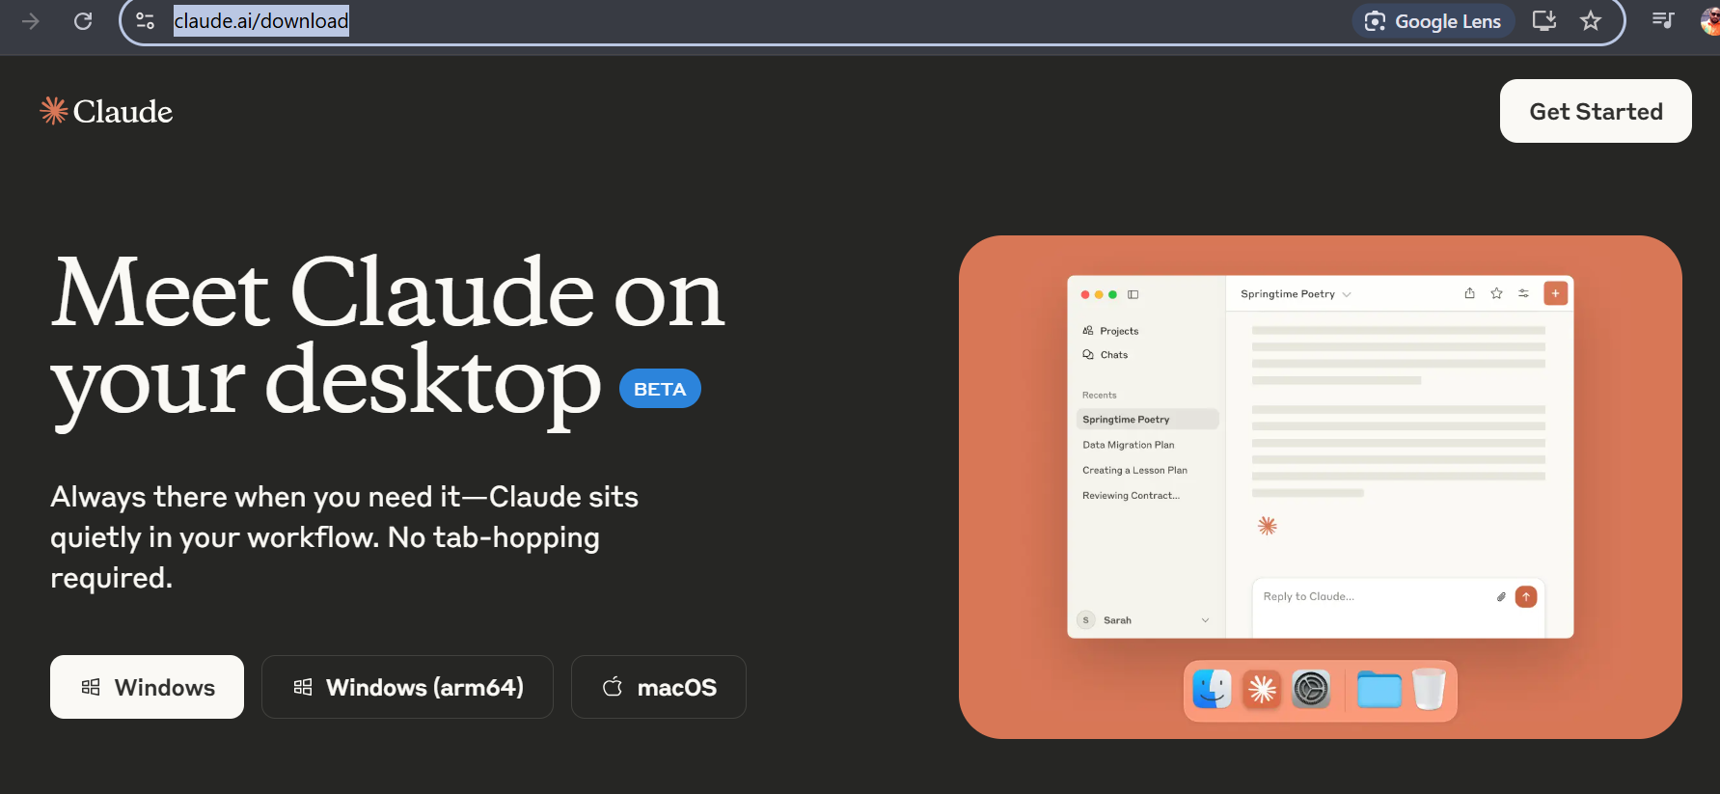
Try to type below question claud unable to access your filesystem that’s why LETS introduced to MCP server
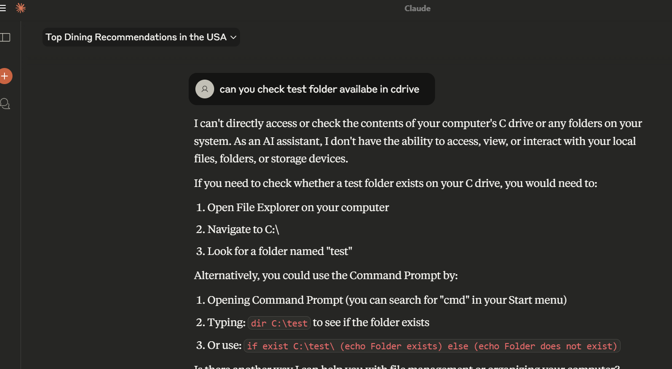
Finally, we install the claude desktop user can test the code
Mcpgithub https://github.com/modelcontextprotocol select on server https://github.com/modelcontextprotocol/servers select on filesystem read the doc
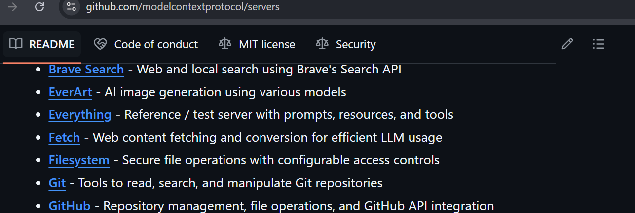
from the filesystem copy the npx code (referred below one)
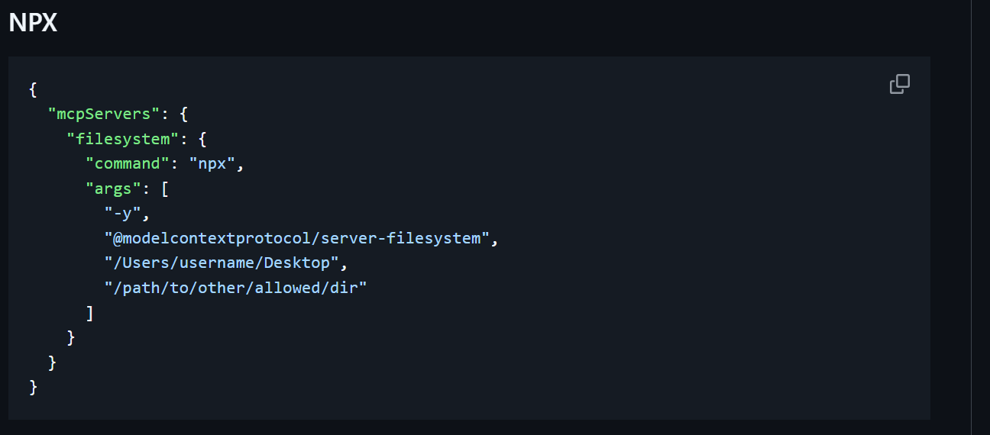

Open claude desktop left side 3 line File menu settings Developer edit configuration claude_desktop_config.json will be create on
C:\\Testing after that paste the npx code ( make sure no space )
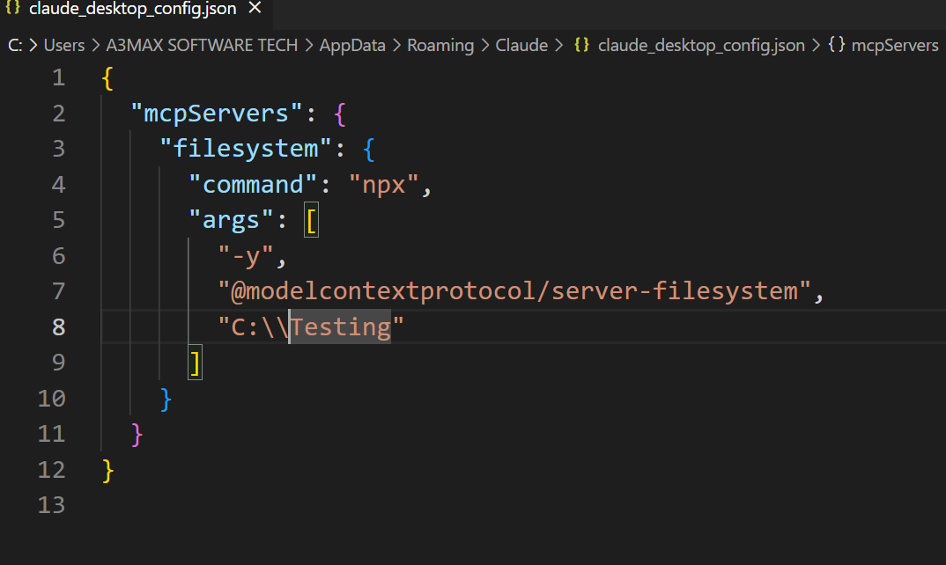
I created my own directory add 2 notepad file
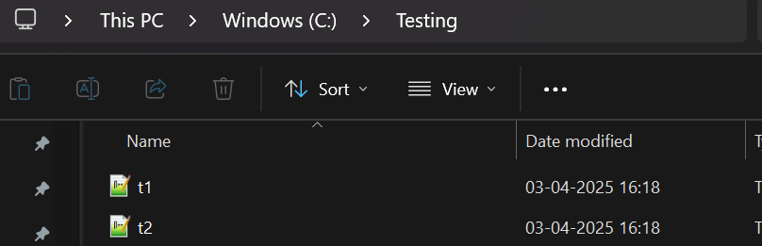
Next step is npx means node so you need to install the node before that you need to check the node below error message will appear
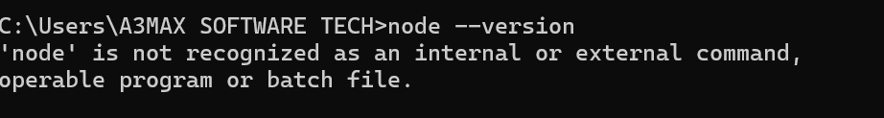
From the google download nodejs https://nodejs.org/en/download now try code 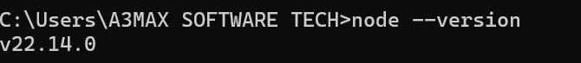
Still if it not work then you need to create environment variable using below steps
Start search with env edit the system environment variable select system variable do not select user variable edit path
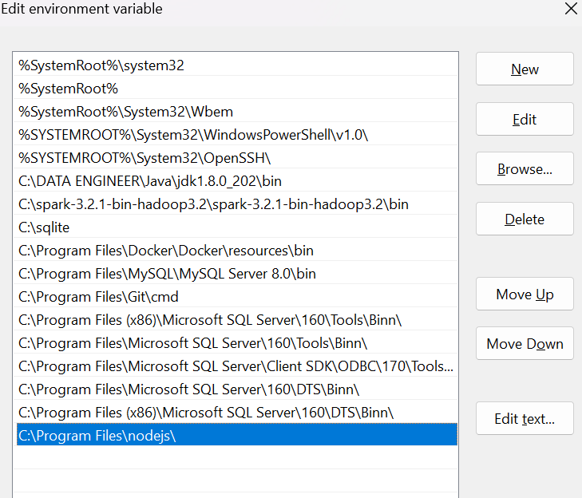

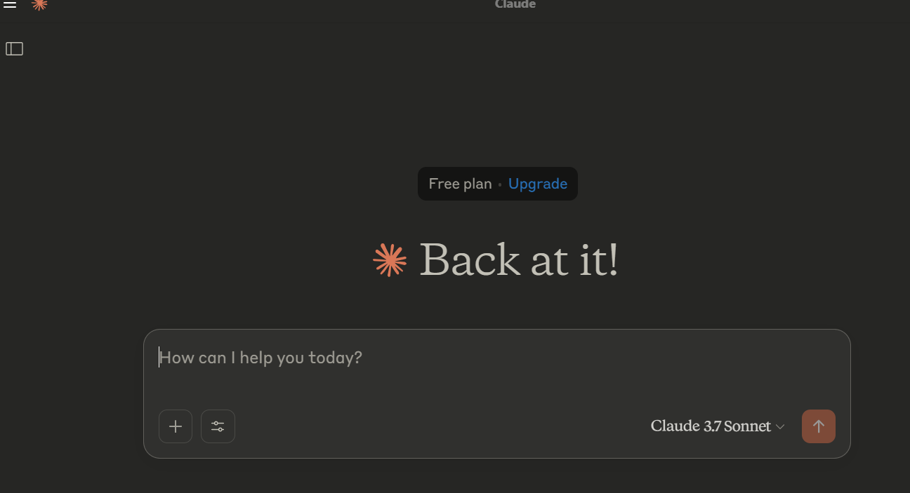
After edi the configure json then you can get to see below option
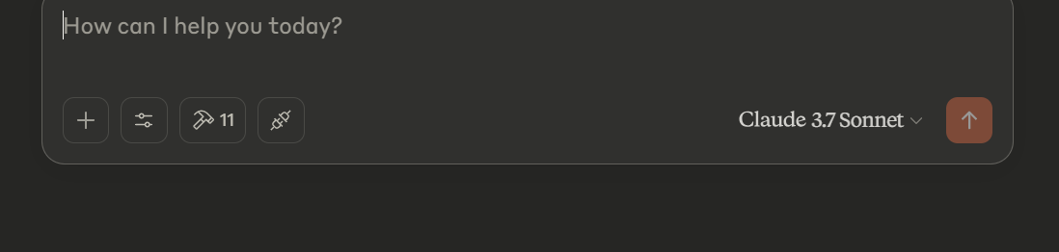
Select on hammar icon you can able to see list of mcp
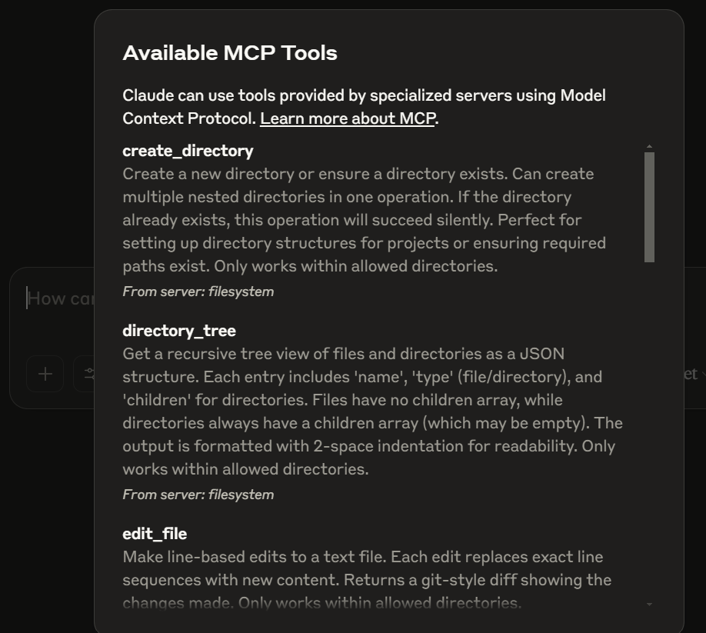
Go to the claude desktop ask question what files you have in desktop
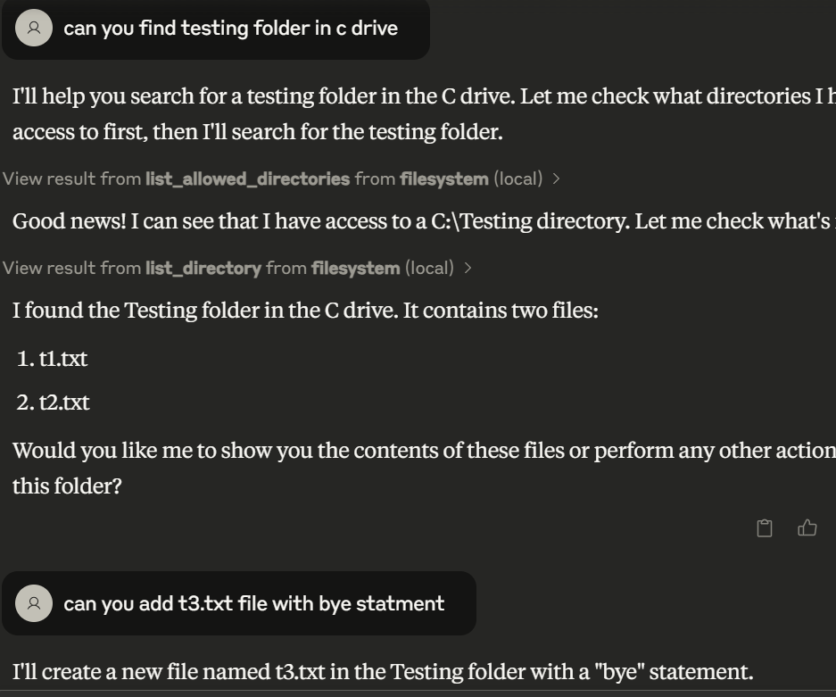
Mcp server will add the next text file to the drive.
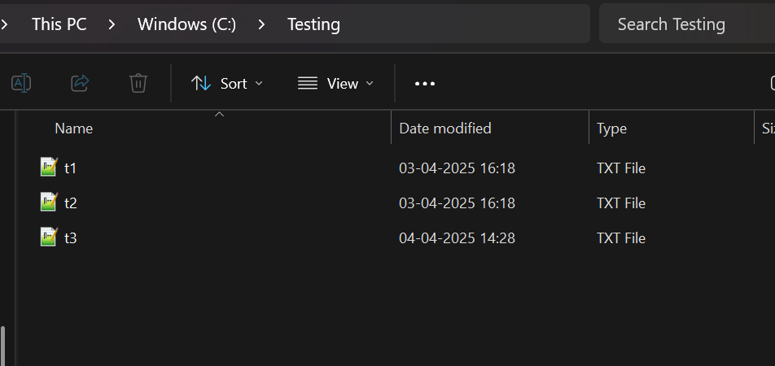

Lets Add another server

Mcp github server community server Airbnb copy the npx paste in config file
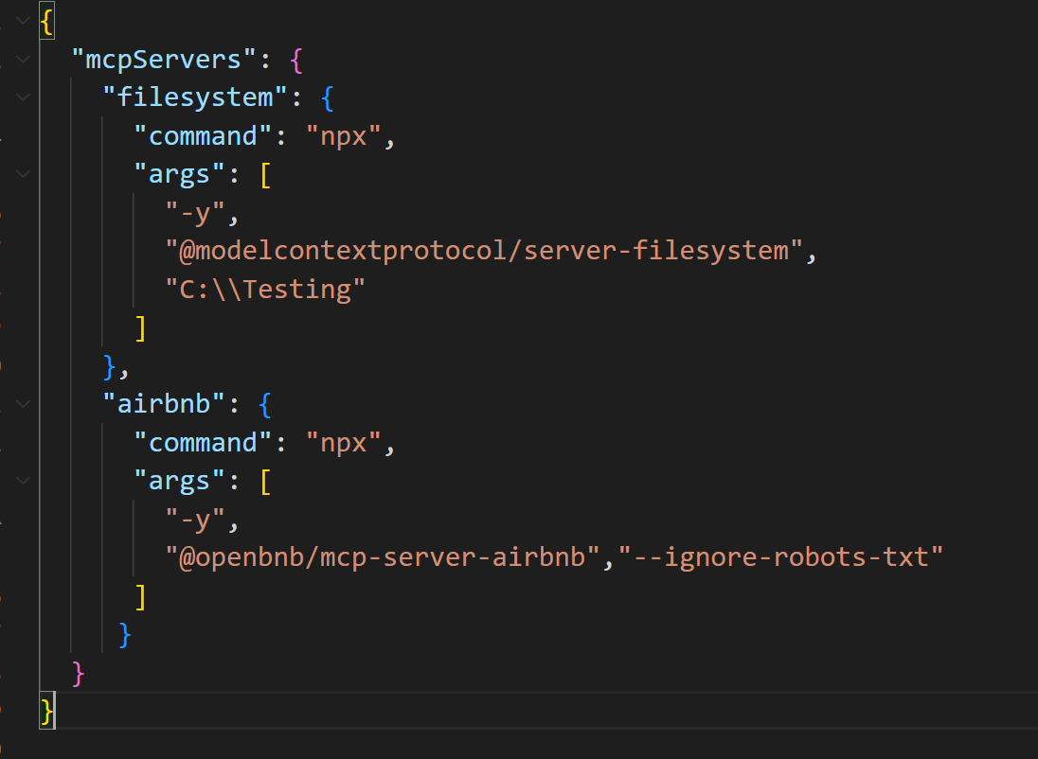
Claud desktop you can view 2 more mcp server will be added check the hammar icon
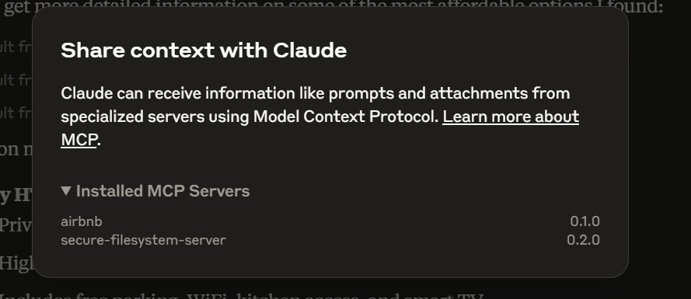
Below question I asked to claud claud can access the mcp
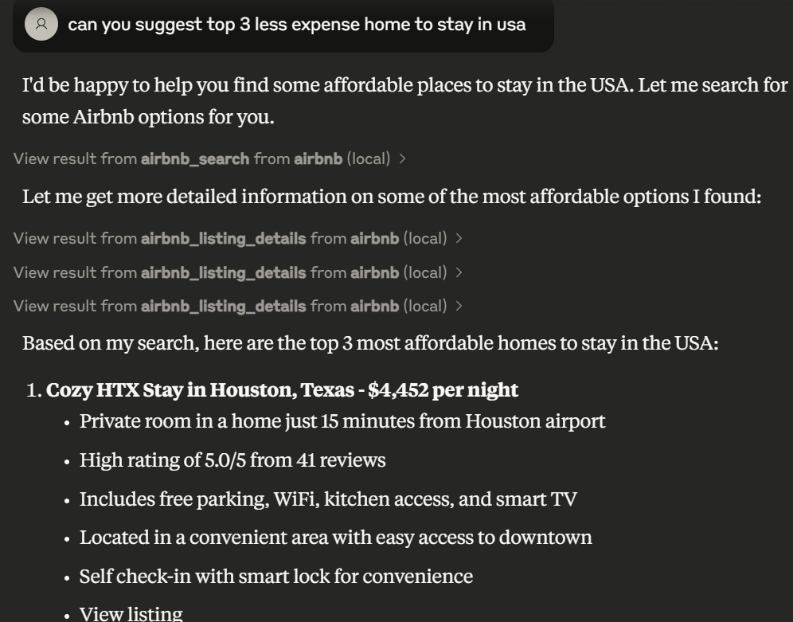

This the way any one can add mcp server as much as possible

